**SMART STAR EXAMINATIONS BOARD**

**END OF TERM ONE EXAMINATION - 2024**

**ENGLISH**

**MIDDLE CLASS**

My name is…………………………………………..

1. **Copy the letter sound.**

|  |  |  |  |  |
| --- | --- | --- | --- | --- |
| **a** | **b** | **c** | **d** | **e** |
|  |  |  |  |  |

1. **Circle the odd man out.**

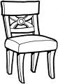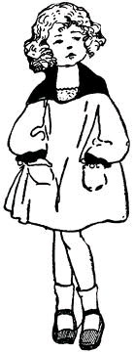

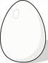

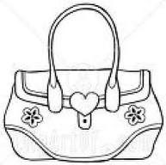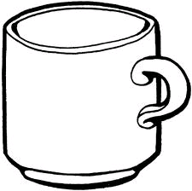

1. **Read and match.**

**book**

**mat**

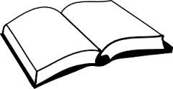

**tin**

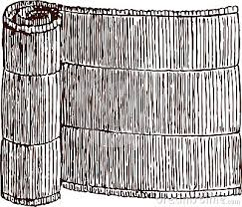

**bag**

1. **Read and shade.**

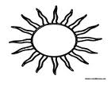

**Yellow**



**blue**

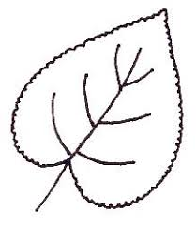

**green**

1. **Match the same.**

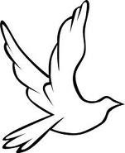

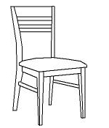

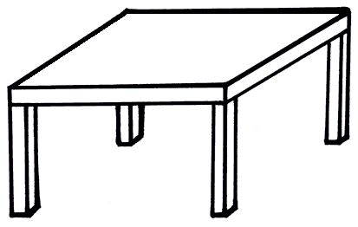



1. **Copy the same.**

|  |  |  |
| --- | --- | --- |
| **box** | **cup** | **E:\PICTURES\Typist Diagrams\food\egge.jpg egg** |
|  |  |  |

**END**